**change connection timeout in pg_admin:-**

Step1:- connect to pg_admin & Click on **Servers** → Right-click your **database server** → **Disconnect**

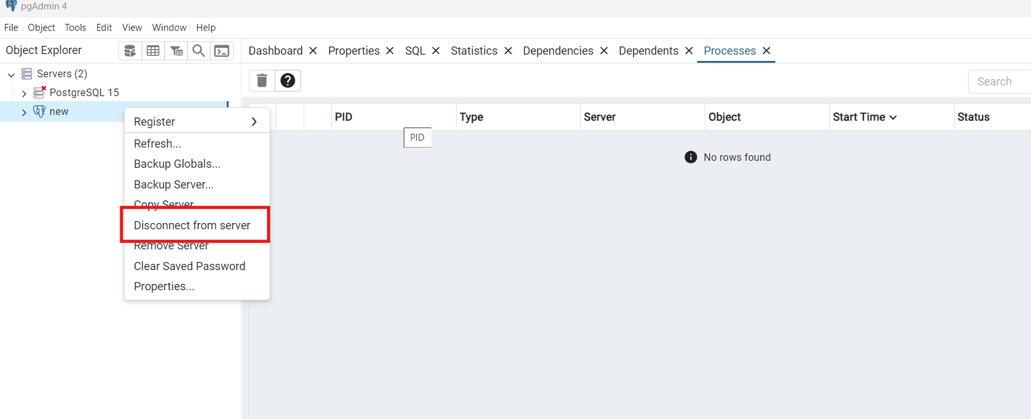

Step2:- Right-click again → **Properties**

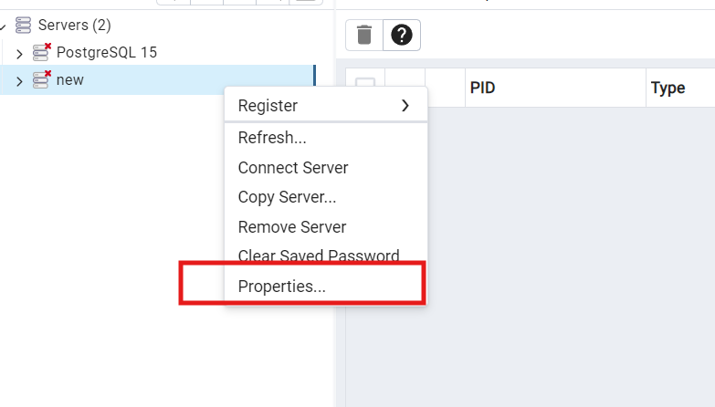

Step 3:- Go to the **"Parameter"** tab

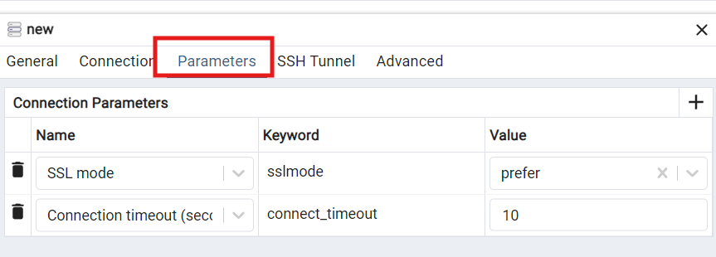

Step 4:- change connection_timeout 10 to 30 & Save

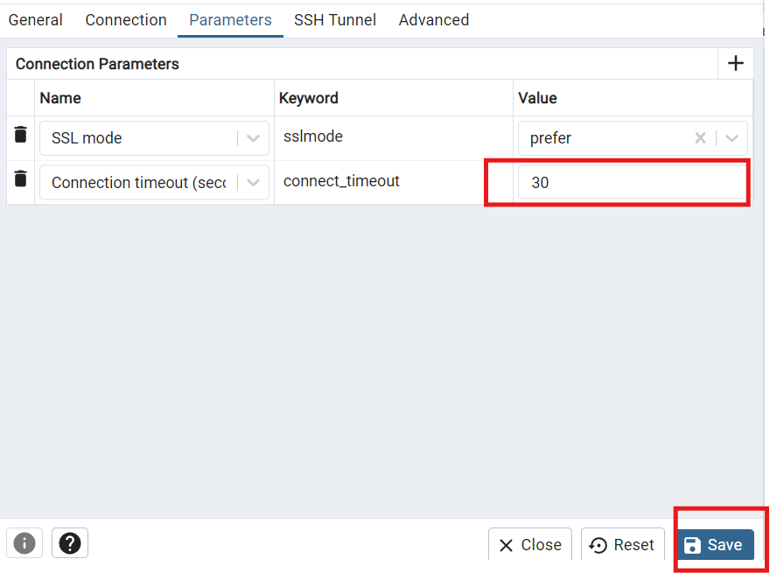

Step 5:- connect server & validate changes are made or not

